Appendices
Appendix A
Didactic implementation
Description of activities
Week 1
Overall objective: Ss will be able to discuss the habits and events happening at the time.
Unit 1: Your world  Language Focus: Questions and short answers and Present simple and Present continuous | Objective | Activities | Final project activities
 | Ss will get to know each other. | Icebreaker: 2 Truths and 1 Lie. Ss will interact with the whole group to identify personal information about themselves and the others. Tools: padlet and wheel of names | Discuss the rules and the explanations that teachers will give.
 | Objective | Activities | Final project activities
 | Ss will be able to talk about daily life activities and events in the present by using present simple and present continuous. | The Challenge Board for Students: It will be carried out through an interactive template with a grid with customizable challenges and questions related to the main topic of the unit. | Make groups of 3 students. This group will be working together until the final project submission. Choose the name of the group and set the first idea for the magazine.

Week 2
Overall objective: Ss will be able to share their memories of past events.
Unit 2: Memory  Language Focus: Past simple and Past continuous (used to and would) | Objective | Activities | Final project activities
 | Ss will use sentence starters and useful language to describe past events. | Board game: Through this game, Ss will talk about specific activities done in the past. Each space on the board contains useful language starters to talk about past events that students will need to come up with a full sentence within 30 seconds. | Take notes about teachers’ examples of how to provide people with tips and pieces of advice. Additionally, search for information about pandemics in the past. Try to find how they managed to overcome it.
 | Objective | Activities | Final project activities
 | Ss will be able to retell a short story about an important past event. | My first lockdown: students will have 5 minutes to talk about what they did and were doing when the national lockdown was announced. | Write down 5 to 7 tips/pieces of advice to cope with the pandemic (these tips can be personal or provided by experts) considering the category given by the teachers (mental health, physical health, academically and extra). Try to compare your tips with past pandemic handling.

Week 3
Overall objective: Ss will be able to compare different places through different ways of comparing.
Unit 3: Across the globe  Language Focus: Comparatives and Superlatives. Different ways of comparing | Objective | Activities | Final project activities
 | Ss will be able to compare places through comparative and superlative forms. | Across the globe: through a presentation template, students will review the comparative and superlative forms for one-, two- and three-syllable adjectives. The template will contain a brief recap of comparative and superlative forms and activities.  My travel agency: in this activity, students will play the roles of tour operators. First, they will be given different traveling destinations. Second, they will be paired with a classmate. Third, they will have to compare their destinations to their classmates to convince the rest of the class to choose their destination. Finally, once all students have spoken, they will vote for their favorite travel operator. | Share your tips with your group and select the ones that will be presented.
 | Objective | Activities | Final project activities
 | Ss will be able to compare things and people through alternative comparative forms. | Different ways of comparing: through an interactive template, students will review different ways of comparing people and things (i.e., exactly the same as, the same as, about the same as, different from, completely different from, fewer, less, etc.). The template will show students pairs of images that require them to provide a comparison based on what they see in the pictures.  10-year challenge: in this activity, students will have to work in groups and report orally how the world has changed in a decade (the cities, the environment, the people, food, etc). | Create the script that will be used for the video. Choose an appropriate appealing format.

Week 4
Overall objective: Ss will be able to answer questions related to past events connected to the present.
Unit 4: Real lives  Language Focus: Present perfect and Past simple, Present perfect simple and Present perfect continuous | Objective | Activities | Final project activities
 | Ss will be able to retell a famous person’s life story by using present perfect, and past simple. | What have they done?: Through a presentation in which famous people’s lives are portrayed, students will review past simple and present perfect sentence formation. At the end of the presentation, the students will have to answer a series of questions related to the famous people in the presentation. If students answer correctly, they will win a badge which will be accumulated to their individual badge tracker.  The ‘have you ever’ game: in this activity, students will be asked a series of questions that will elicit answers in present perfect and past simple forms. If students answer correctly, they will win a badge which will be accumulated to their individual badge tracker. | Share your script with the teachers and make the changes that will be suggested (if necessary).
 | Objective | Activities | Final project activities
 | Ss will be able to describe aspects of their lives through the present perfect simple and the present perfect continuous. | The Most Inspiring People Alive: through an interactive template in which we described facts about the most inspiring people alive, students will review the present perfect simple and the present perfect continuous. At the end of this presentation, students will be asked a series of questions related to the most inspiring people alive. They are expected to answer by using present perfect simple and present perfect continuous. If students answer correctly, they will win a badge which will be accumulated to their individual badge tracker.  The present perfect and present perfect continuous fortune wheel: through this activity, students will be asked a series of questions that will elicit answers with present perfect simple and present perfect continuous. If students answer correctly, they will win a badge which will be accumulated to their individual badge tracker. | Rehearse how these tips will be presented and record a3-minute live test video to share with teachers.

Week 5
Overall objective: Ss will be able to talk about future plans and ambitions.
Unit 5: Go for it!  Language Focus: Future forms and Future clauses with if, when, unless, etc. | Objective | Activities | Final project activities
 | Ss will be able to use future forms to talk about their ambitions and plans for their future. | Ambitions: Ss will be divided into 4 groups where they will play with virtual flashcards. The flashcards will contain different words, i.e. Vacations, jobs, etc. Ss will have to express their plans or ambitions for each of them, if they get it right, the team wins a point. | Improve video based on the feedback provided by teachers.
 | Objective | Activities | Final project activities
 | Ss will be able to talk about the people they prefer for a job. | Role play game: Ss will be chosen randomly, and they will make up a conversation with a random selection of their chosen role and job. There are two main roles: interviewer and interviewee, as well as many possible occupations. | Check classmates’ videos and make suggestions whenever it is needed.

Week 6
Overall objective: Ss will be able to retell historical and important information.
Unit 6: True Stories  Language Focus: Past perfect/ Reported speech | Objective | Activities | Final project activities
 | Ss will be able to talk about important historical events using past perfect. | Historical events: Ss will search for some major historical events that happened in specific moments of their life, i.e. When I was born, the Berlin wall had already been demolished. Then, Ss will create a short presentation with the events, and they will share it with the rest of the class. | Choose the name of the final product and set the main moments of the video.
 | Objective | Activities | Final project activities
 | Ss will be able to report or retell something that was said before without using the same words. | Reported board game: Ss will play with a virtual board game which is filled with some words, i.e sister-said, that Ss will use to create reported speech statements, based on real events of their lives. | Start recording the video. It is important to take some time to edit the video.

Week 7
Overall objective: Ss will be able to make a recommendation of a show.
Unit 7: Must see!  Language Focus: -ed, -ing adjectives and The passive | Objective | Activities | Final project activities
 | Ss will be able to argue whether they like or dislike a show by using descriptions ended in -ed or -ing. | Become an influencer: Ss will record a video via Flipgrid by recommending a TV show they find interesting. | Space for editing the final details of the video.
 | Objective | Activities | Mini project
 | Ss will be able to suggest, comment on and evaluate a TV show. | Defend your ideas: Taking the video previously recorded, they must defend their recommendation in a debate that must prepare counter arguments against it. | Submit the final video.

Week 8
Overall objective: Ss will be able to finish the creation of a vlog about their life.
Posttest application | Objective | Activities | Mini project
 | Ss will be able to answer questions on topics covered in class. | Each student will have a series of spoken challenges regarding all the contents seen in class. | Showroom: Ss will check their classmates’ videos and provide feedback about the ones they liked the most.
 | Objective | Activities | Mini project
 | Ss will be able to create conversations about the topics seen in class. | In pairs, Ss will take a random topic to develop a conversation regarding the contents seen in class. | Self-evaluation. Share your experiences, positive and negative comments about your group work, the activities and classroom development.

Appendix B
Socio-demographic Questionnaire
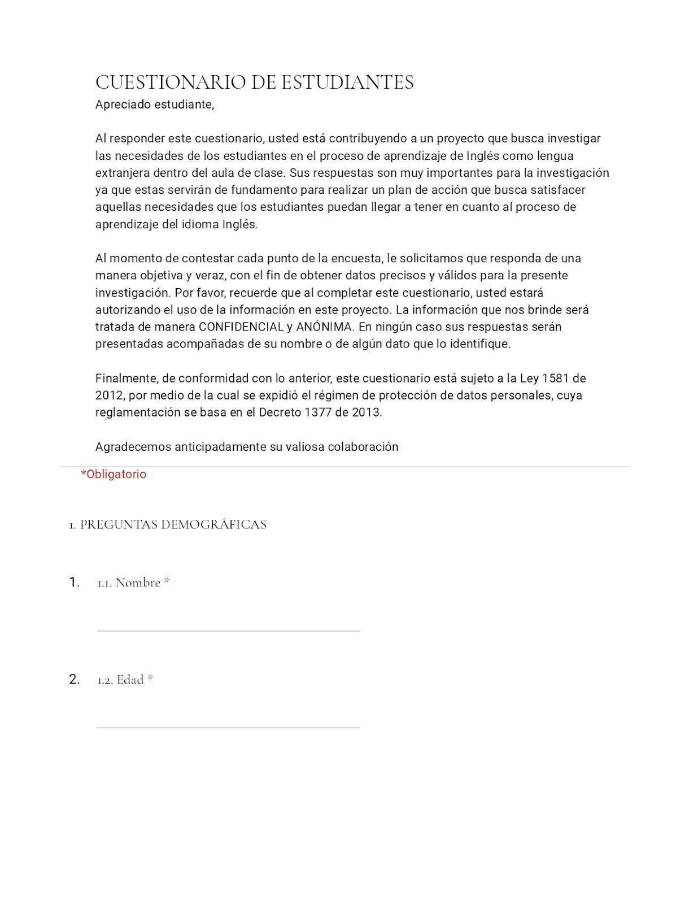

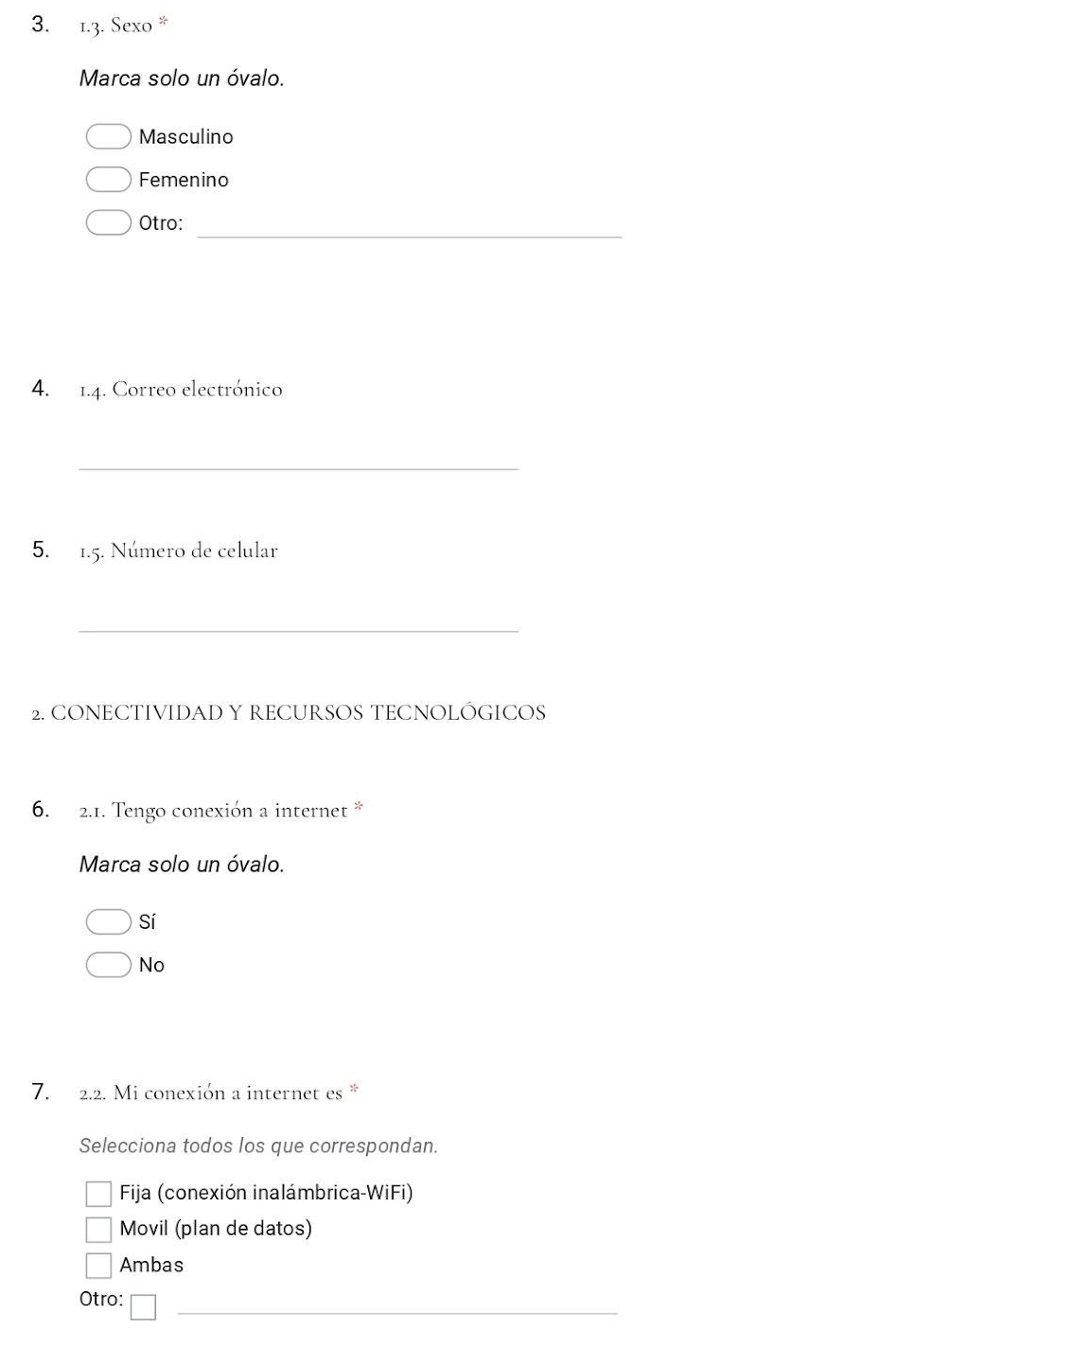
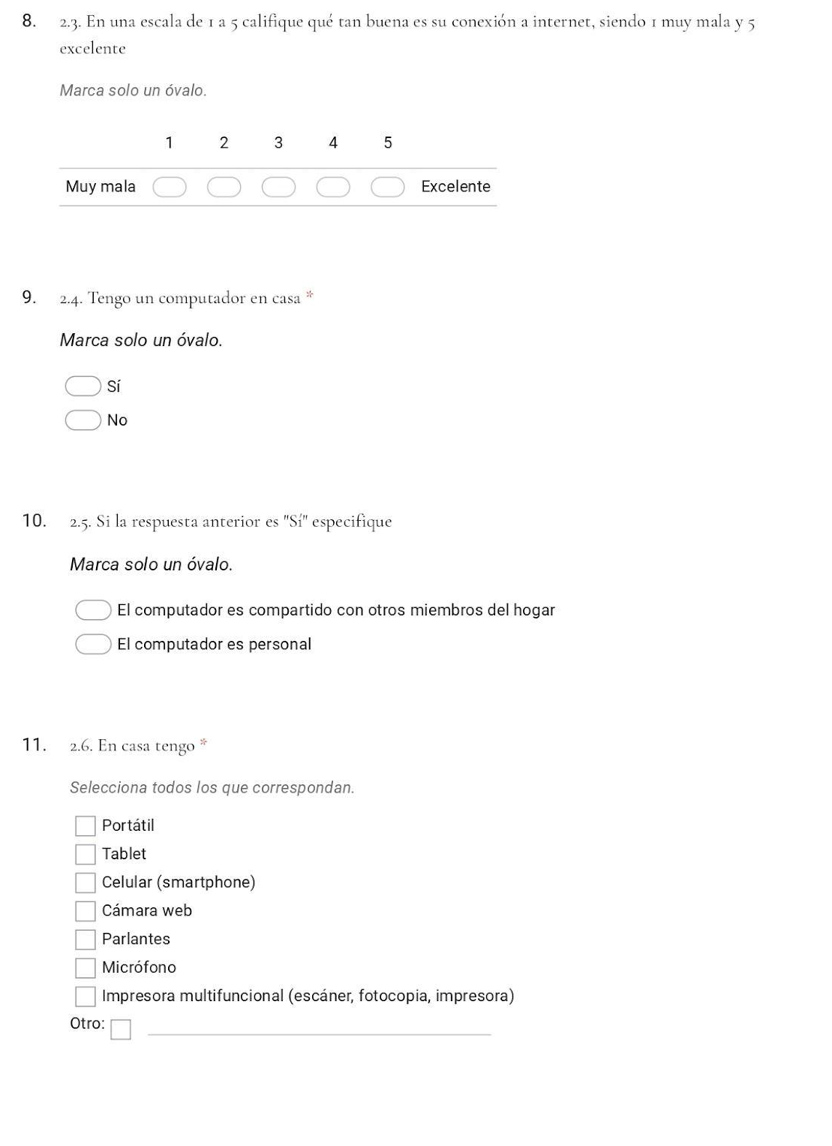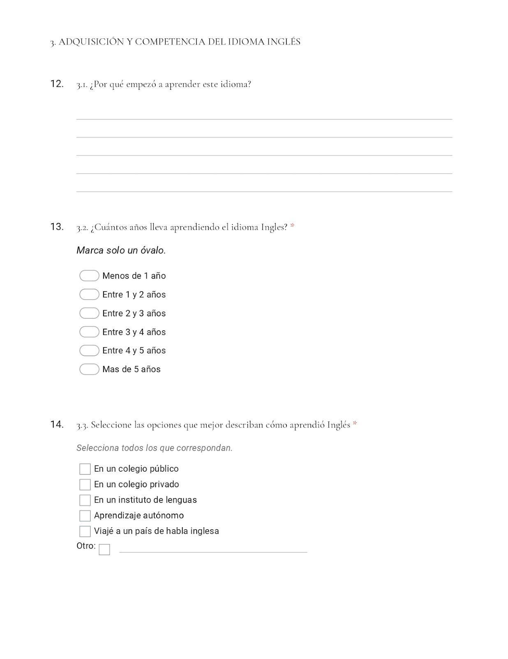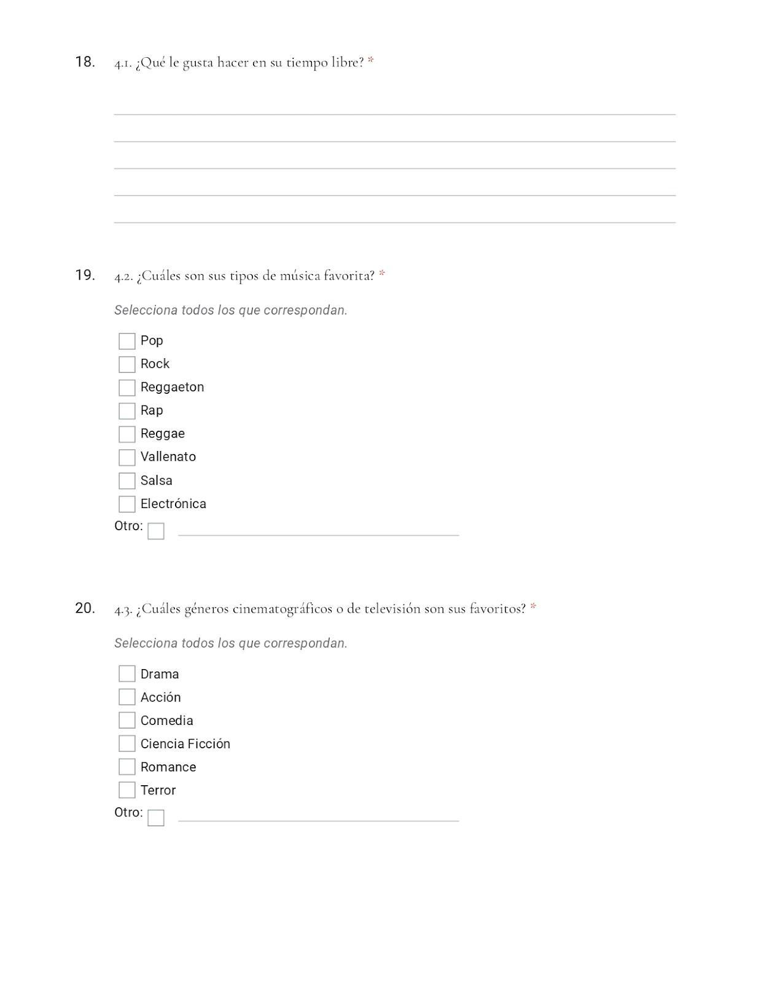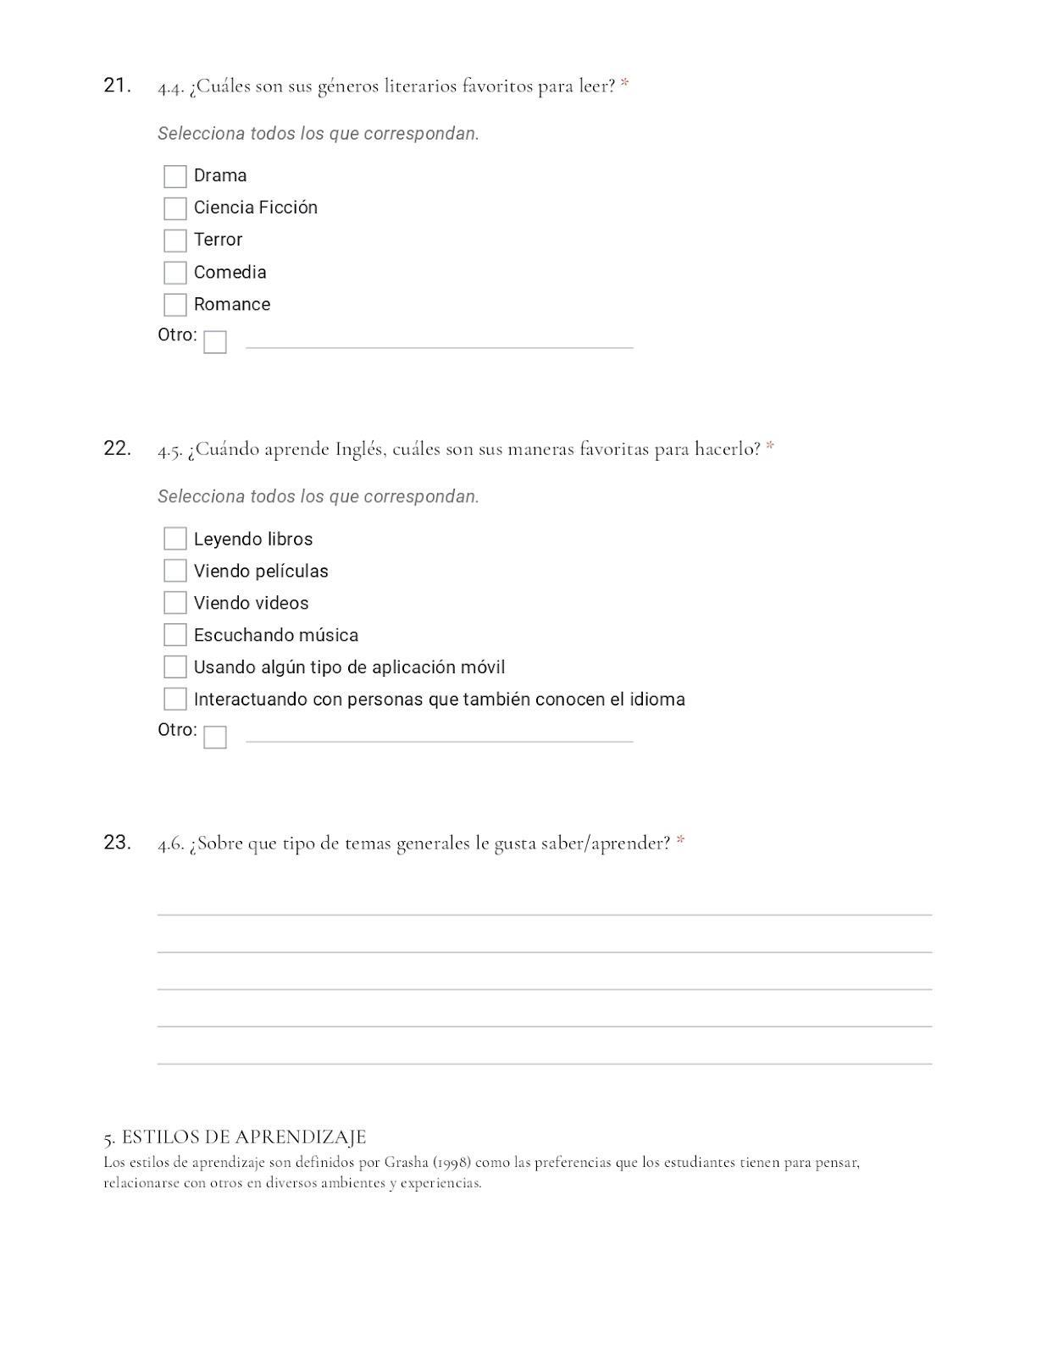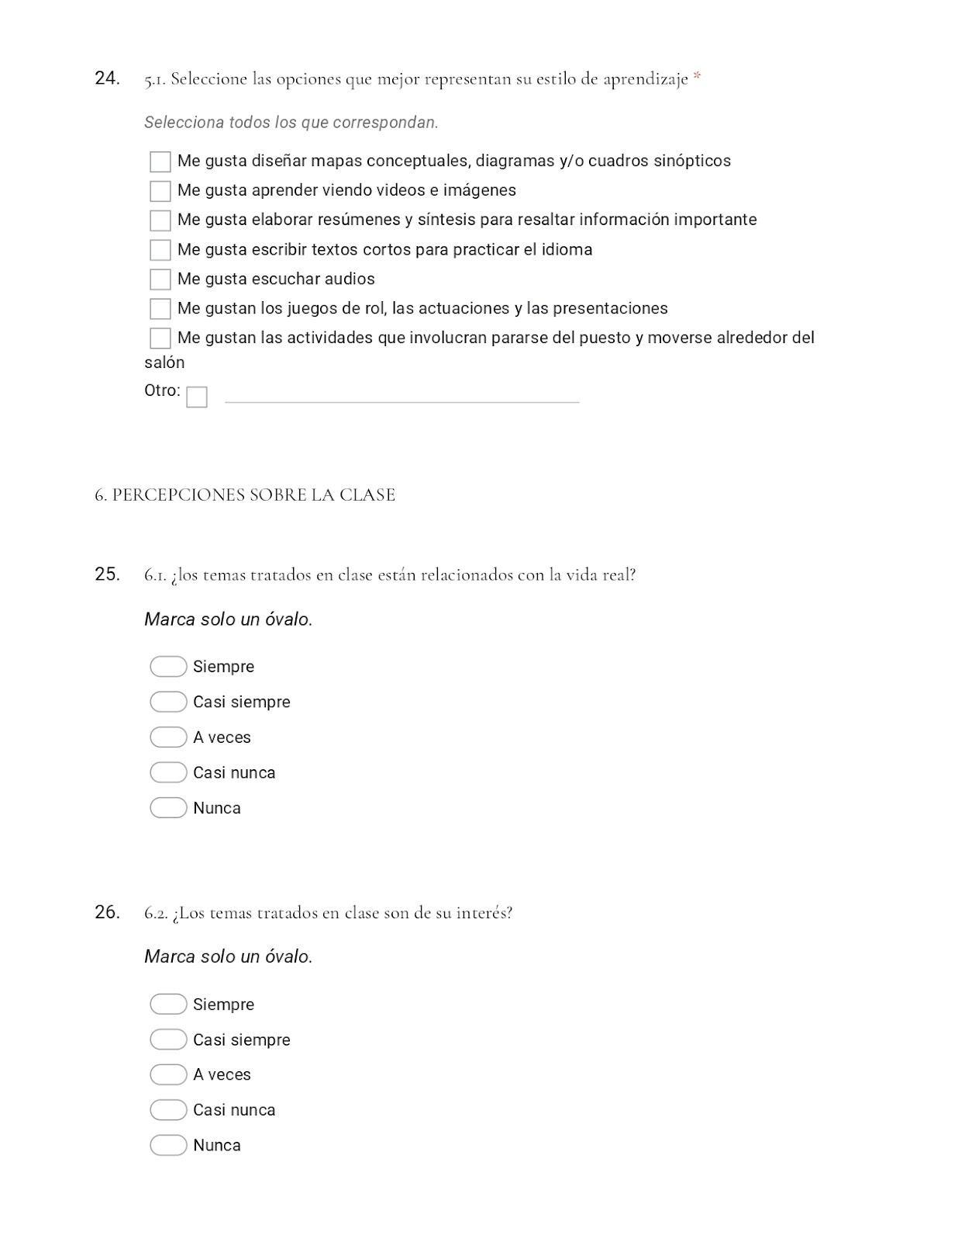
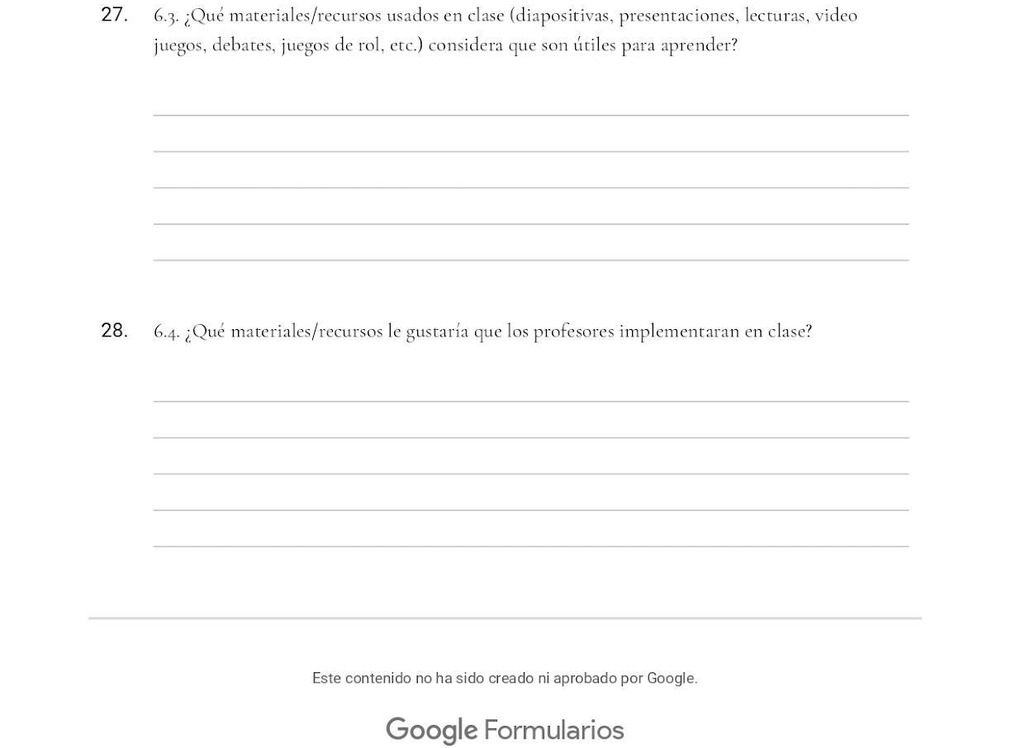
Appendix C
Pretest and Posttest
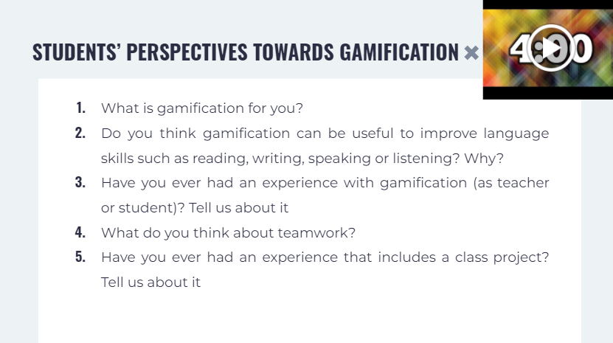
Appendix D
Pretest and Posttest
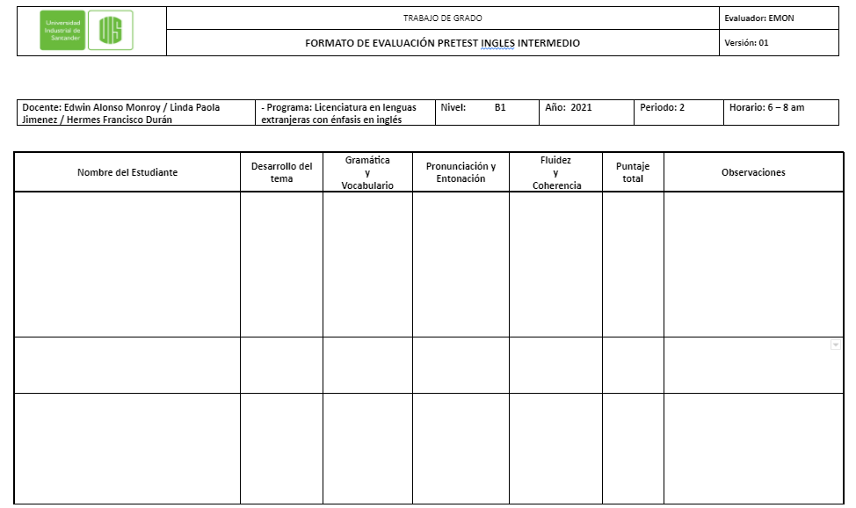
Appendix E
Open-ended questionnaire
