Apéndice F. Código del modelo hibrido

#https://www.analyticsvidhya.com/blog/2020/10/how-to-create-an-arima-model-for- time-series-forecasting-in-python/
#importar librerías necesarias import numpy as np
import pandas as pd
import matplotlib.pyplot as plt
%matplotlib inline #leemos el dataset
df=pd.read_csv('colcap1.csv') df.head()
# Cambiar nombre de columnas y agregar index df.columns=["Fecha","Rendimiento"]
df.head() df.describe()
df.set_index('Fecha',inplace=True)
#graficar
from pylab import rcParams rcParams['figure.figsize'] = 15, 7 df.plot()
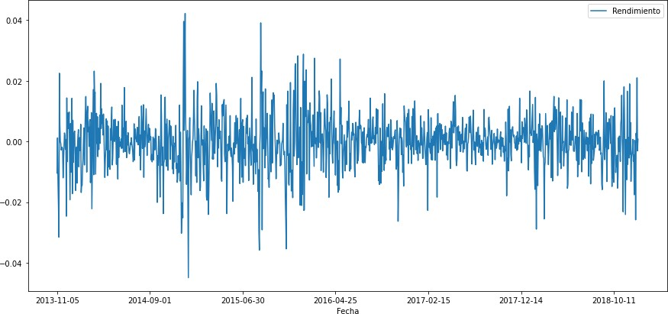

#importar
from statsmodels.tsa.stattools import adfuller test_result=adfuller(df['Rendimiento'])
def adfuller_test(sales): result=adfuller(sales)
labels = ['ADF Test Statistic','p-value','#Lags Used','Number of Observations'] for value,label in zip(result,labels):
print(label+' : '+str(value) )
if result[1] <= 0.05:
print("strong evidence against the null hypothesis(Ho), reject the null hypothesis.
Data is stationary") else:
print("weak evidence against null hypothesis,indicating it is non-stationary ") adfuller_test(df['Rendimiento'])
ADF Test Statistic : -29.428630662743533 p-value : 0.0
#Lags Used : 0
Number of Observations : 1252
strong evidence against the null hypothesis(Ho), reject the null hypothesis. Data is station ary
from pandas.plotting import autocorrelation_plot autocorrelation_plot(df['Rendimiento']) plt.show()
#HALLAR EL MEJOR MODELO ARIMA optimo en los datos # Import the library
from pmdarima import auto_arima # Ignore harmless warnings import warnings
warnings.filterwarnings("ignore")
stepwise_fit = auto_arima(df['Rendimiento'], start_p = 2, start_q = 2, max_p = 3, max_q = 3, m = 12,
start_P = 0, seasonal = True, d = None, D = 1, trace = True,
error_action ='ignore', # we don't want to know if an order does not
work
suppress_warnings = True, # we don't want convergence warnings stepwise = True) # set to stepwise
# To print the summary stepwise_fit.summary()
Performing stepwise search to minimize aic
ARIMA(2,0,2)(0,1,1)[12] intercept : AIC=-3047.709, Time=3.37 sec ARIMA(0,0,0)(0,1,0)[12] intercept : AIC=-2838.758, Time=0.31 sec ARIMA(1,0,0)(1,1,0)[12] intercept : AIC=-2961.229, Time=0.76 sec ARIMA(0,0,1)(0,1,1)[12] intercept : AIC=-3053.185, Time=3.59 sec ARIMA(0,0,0)(0,1,0)[12] : AIC=-2840.709, Time=0.10 sec ARIMA(0,0,1)(0,1,0)[12] intercept : AIC=-2844.866, Time=0.42 sec
ARIMA(0,0,1)(1,1,1)[12] intercept : AIC=inf, Time=6.47 sec ARIMA(0,0,1)(0,1,2)[12] intercept : AIC=-3069.167, Time=4.47 sec ARIMA(0,0,1)(1,1,2)[12] intercept : AIC=-3067.369, Time=14.38 sec ARIMA(0,0,0)(0,1,2)[12] intercept : AIC=-3066.474, Time=5.52 sec ARIMA(1,0,1)(0,1,2)[12] intercept : AIC=-3067.434, Time=12.09 sec ARIMA(0,0,2)(0,1,2)[12] intercept : AIC=-3067.526, Time=9.73 sec ARIMA(1,0,0)(0,1,2)[12] intercept : AIC=-3068.626, Time=3.56 sec ARIMA(1,0,2)(0,1,2)[12] intercept : AIC=-3065.703, Time=5.46 sec ARIMA(0,0,1)(0,1,2)[12] : AIC=-3074.840, Time=5.37 sec ARIMA(0,0,1)(0,1,1)[12] : AIC=-3076.240, Time=1.06 sec ARIMA(0,0,1)(0,1,0)[12] : AIC=-2846.832, Time=0.17 sec ARIMA(0,0,1)(1,1,1)[12] : AIC=inf, Time=2.28 sec ARIMA(0,0,1)(1,1,0)[12] : AIC=-2963.654, Time=0.36 sec ARIMA(0,0,1)(1,1,2)[12] : AIC=inf, Time=6.99 sec ARIMA(0,0,0)(0,1,1)[12] : AIC=inf, Time=1.81 sec ARIMA(1,0,1)(0,1,1)[12] : AIC=inf, Time=2.00 sec ARIMA(0,0,2)(0,1,1)[12] : AIC=-3074.680, Time=2.32 sec ARIMA(1,0,0)(0,1,1)[12] : AIC=-3076.573, Time=2.64 sec ARIMA(1,0,0)(0,1,0)[12] : AIC=-2846.184, Time=0.04 sec ARIMA(1,0,0)(1,1,1)[12] : AIC=-3046.472, Time=0.67 sec ARIMA(1,0,0)(0,1,2)[12] : AIC=-3074.506, Time=6.31 sec ARIMA(1,0,0)(1,1,0)[12] : AIC=-2963.163, Time=0.34 sec
ARIMA(1,0,0)(1,1,2)[12] : AIC=inf, Time=7.32 sec ARIMA(2,0,0)(0,1,1)[12] : AIC=inf, Time=1.85 sec ARIMA(2,0,1)(0,1,1)[12] : AIC=-3072.496, Time=4.24 sec ARIMA(1,0,0)(0,1,1)[12] intercept : AIC=-3052.589, Time=1.07 sec Best model: ARIMA(1,0,0)(0,1,1)[12]
Total fit time: 117.067 seconds

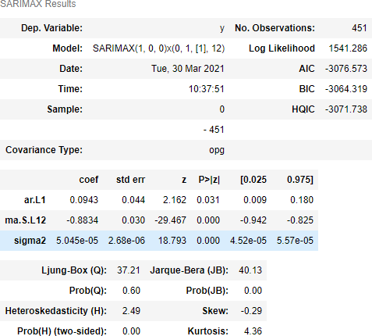
#APLICANDO 1 0 0 0 1 1 12
from statsmodels.tsa.arima_model import ARIMA model=ARIMA(df['Rendimiento'],order=(1,0,0)) model_fit=model.fit()
model_fit.summary()
import statsmodels.api as sm
model=sm.tsa.statespace.SARIMAX(df['Rendimiento'],order=(1, 0, 0),seasonal_order=(0,1,1,12))
results=model.fit() df['forecast']=results.predict(start=800,end=1250,dynamic=True) df[['Rendimiento','forecast']].plot(figsize=(12,8))

Predicción modelo ARIMA
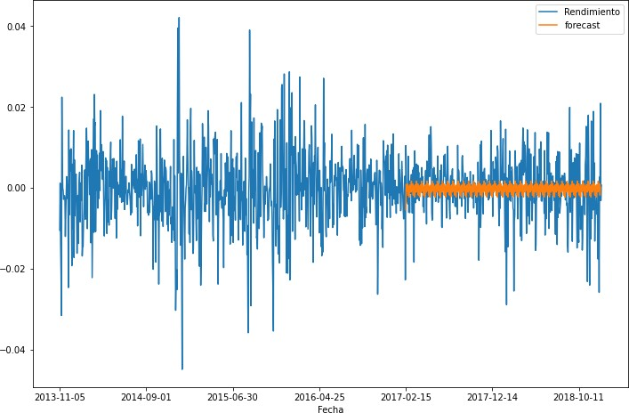
#comenzamos lstm - redes neuronales import warnings warnings.simplefilter("ignore")
#impoRTANDO PAQUETES
import pandas
import matplotlib.pyplot as plt import numpy
import matplotlib.pyplot as plt
import pandas import math
from keras.models import Sequential from keras.layers import Dense
from keras.layers import LSTM
from sklearn.preprocessing import MinMaxScaler from sklearn.metrics import mean_squared_error import numpy as np
from statsmodels.tsa.seasonal import seasonal_decompose #GRAFICANDO
dataset = pandas.read_csv('colcap3.csv', usecols=[0,1], engine='python', skipfooter=3, index_col ='Fecha')plt.plot(dataset) plt.show()

Nuevo dataset

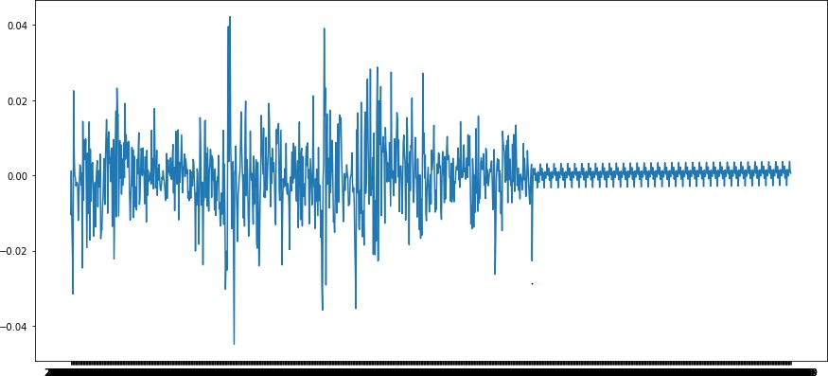

# normalizando
scaler = MinMaxScaler(feature_range=(0, 1)) dataset = scaler.fit_transform(dataset)
# split into train and test sets
train_size = int(len(dataset) * 0.7) #se entrena con 0.7 test_size = len(dataset) - train_size
train, test = dataset[0:train_size,:], dataset[train_size:len(dataset),:] print(len(train), len(test))
#entrenando con el 90%
# split into train and test sets
train_size = int(len(dataset) * 0.7) #entrena con 0.7 test_size = len(dataset) - train_size
train, test = dataset[0:train_size,:], dataset[train_size:len(dataset),:] print(len(train), len(test))
def create_dataset(dataset, look_back=1): dataX, dataY = [], []
for i in range(len(dataset)-look_back-1): a = dataset[i:(i+look_back), 0] dataX.append(a)
dataY.append(dataset[i + look_back, 0]) return np.array(dataX), np.array(dataY)
look_back = 1
trainX, trainY = create_dataset(train, look_back) testX, testY = create_dataset(test, look_back) trainX.shape
print(testX.shape)
# reshape input to be [samples, time steps, features]

trainX = np.reshape(trainX, (trainX.shape[0], 1, trainX.shape[1])) testX = np.reshape(testX, (testX.shape[0], 1, testX.shape[1]))
# create and fit the LSTM network model = Sequential()
model.add(LSTM(4, input_shape=(1, look_back))) model.add(Dense(1))
model.compile(loss='mean_squared_error', optimizer='RMSProp') model.fit(trainX, trainY, epochs=100, batch_size=10, verbose=2) trainPredict = model.predict(trainX)
testPredict = model.predict(testX) # invert predictions
trainPredict = scaler.inverse_transform(trainPredict) trainY = scaler.inverse_transform([trainY]) testPredict = scaler.inverse_transform(testPredict) testY = scaler.inverse_transform([testY])
# calculate root mean squared error
trainScore = math.sqrt(mean_squared_error(trainY[0], trainPredict[:,0])) print('Train Score: %.2f RMSE' % (trainScore))
testScore = math.sqrt(mean_squared_error(testY[0], testPredict[:,0])) print('Test Score: %.2f RMSE' % (testScore))
Train Score: 0.10 RMSE Test Score: 0.02 RMSE
# shift train predictions for plotting trainPredictPlot = np.empty_like(dataset) trainPredictPlot[:, :] = np.nan
trainPredictPlot[look_back:len(trainPredict)+look_back, :] = trainPredict # shift test predictions for plotting
testPredictPlot = np.empty_like(dataset) testPredictPlot[:, :] = np.nan
testPredictPlot[len(trainPredict)+(look_back*2)+1:len(dataset)-1, :] = testPredict # plot baseline and predictions
plt.plot(scaler.inverse_transform(dataset)) # converts 0-1 back to original number;
plt.plot(trainPredictPlot) #COLOR naranja - PREDICCIONES EN EL ENTRENAMIENTO
plt.plot(testPredictPlot) #COLOR verde - PREDICCIONES PARA EL TEST
plt.show()

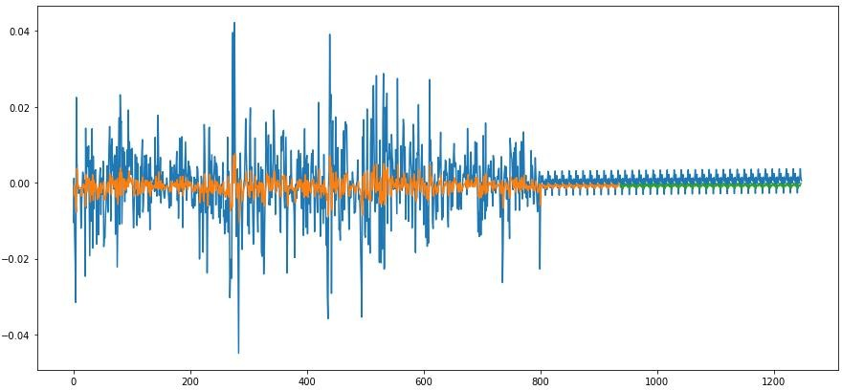
Modelo final

